Costa Rica & Panama Ecological Forecasting II

Identifying Current and Future Areas of Environmental Concern in La Amistad International Park for Resource Management

**Short-Term Forest Change Tool**

**Operating Procedures Guide**

April 7th, 2020

Kate Markham (Project Lead)

Teodora Mitroi

Eder Hernandez

Sharifa Karwandyar

Dr. Marguerite Madden (University of Georgia, Department of Geography)

Dr. Sergio Bernardes (University of Georgia, Department of Geography)

Austin Stone (University of Georgia, Department of Geography)

Previous Contributors:

Molly Azami

Kara Bissonnette

Mahsa Khodaee

Zachary Leslie

Shelby Ingram

**Table of Contents**

Introduction

3

Short - Term Forest Change Tool Overview

3

Step-by-Step Guide 4-7

Explanation of Methodology

7-8

Glossary of Terms

8

Acknowledgements

8

1. **Introduction**

Within 202,230 square miles in Central America, seven percent of all scientifically known life forms exist in the Mesoamercian Biological Corridor. Deforestation is a serious threat to species diversity here, and biological conservation demands greater environmental management efforts. Statues like the Biodiversity Law of 1998 allow the Ministry of Energy and Environment of Costa Rica and the Ministry of Environment in Panama to conserve important ecological features of the La Amistad International Park through environmental management.

The NASA DEVELOP team in Georgia partnered with the Central American Integration System (SICA) to use NASA Earth observation to examine areas of potential land use conflict in the park. A framework known as the Land-Use Conflict Identification Strategy (LUCIS) served as the model for identifying sites of contested land use within the greater La Amistad International Park. To monitor short -term changes in the region of study, the team incorporated forest cover data from the Global Forest Change dataset in Google Earth Engine to create a novel product. The Short-Term Forest Change Tool allows users to monitor forest cover change from various Earth observations that compare Normalized Difference Vegetation Index (NDVI) and Enhanced Vegetation Index (EVI) at any interval of time.

1. **Short -Term Forest Change Tool Overview**
2. **System Overview**

* Type of code: Source code (Calls open source software/libraries)

Coding Language: JavaScript

* Application programming interface: Google Earth Engine (GEE)

1. **User prerequisite knowledge for STFC Tool operation**

* User must have an active Google account to access Google Earth Engine
* User must have area shapefile for study area to upload as an “asset” in Google Earth Engine

1. **Short-Term Forest Change Tool Description**

The STFC Tool operates in Google Earth Engine allowing the end-user with the capability to monitor deforestation in La Amistad International Park on a monthly interval. The tool integrates calculated differences in pixel imagery by comparing EVI and NDVI in a cloud forest area. The team used data from Landsat 8, Sentinel 2 and Terra MODIS to determine if canopy cover changes occurred within the La Amistad International Park. The tool integrates the Hansen Global Forest Change v1.6 with data from 2000-2018 to evaluate only forested areas in La Amistad International Park. Additionally, the tool builds on the previous term’s concept of a deforestation monitoring tool which solely calculates the change in NDVI with no forest assessment.

**III. Using STFC Tool: A Step-By-Step Guide**

1. **Paste code into GEE Code Editor**

Paste the code in the space labeled “New Script” in the GEE Code Editor, displayed in the upper-middle box in *Figure 1.*

The user can access the platform by pasting this link: code.earthengine.google.com).

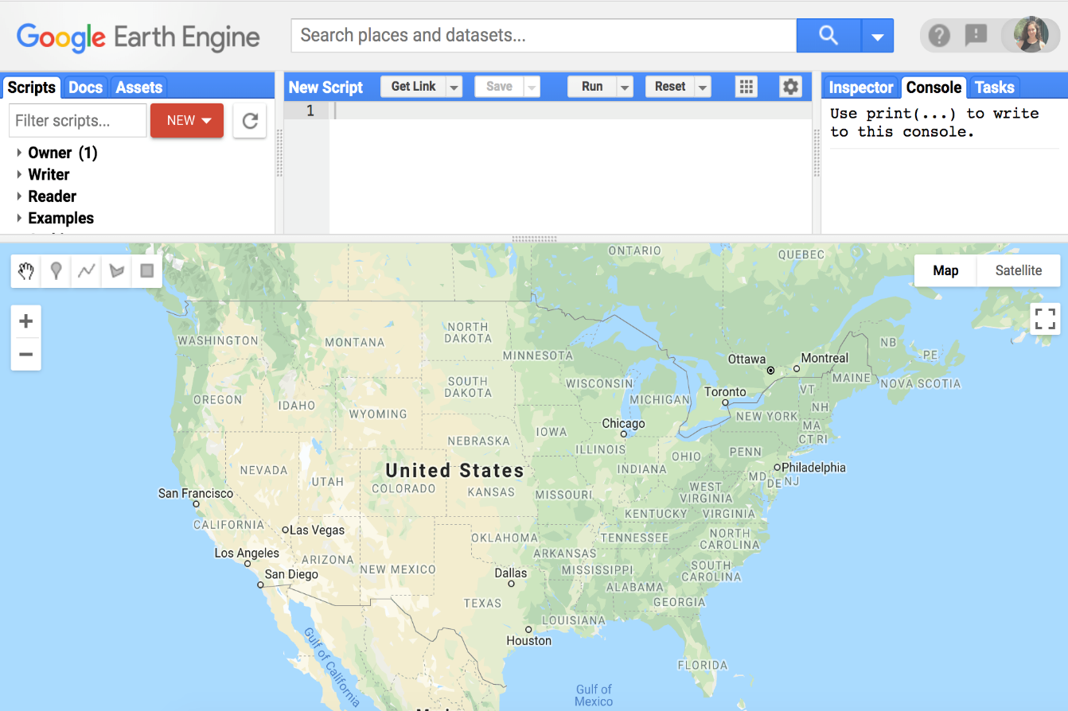 *Figure 1.* Google Earth Engine API

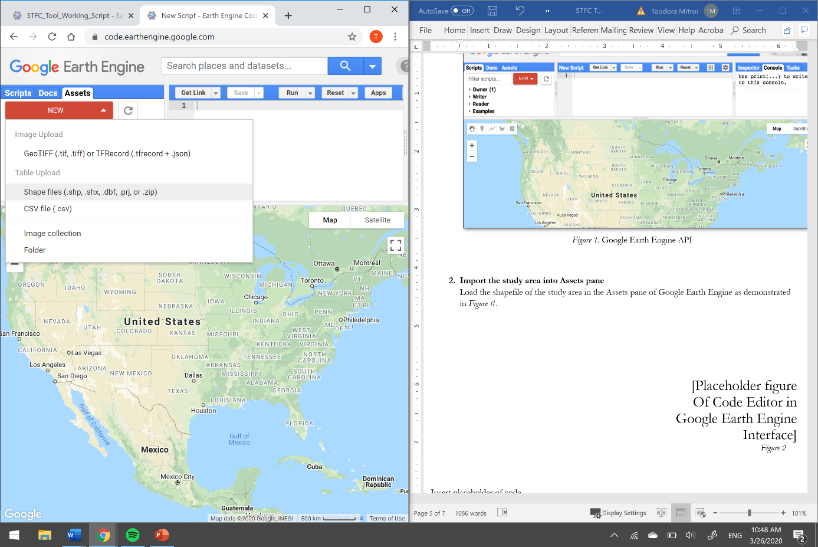

1. **Import the study area into Assets pane (optional)**

Load the shapefile of the study area in the Assets pane of Google Earth Engine by clicking “Assets” on the left side of the GEE. Afterwards, click “NEW” and select Shape files, as seen in *Figure 2.*

“SELECT” Source files (.shp must be accompanies by .dbf and .shx), and name the Asset ID.

*Figure 2.* After clicking “NEW”, select Shape files to add study area of choice

1. **Change the path name (optional)**

Find the first section of the code labeled “Enter Study Area” on line 101. Change the directory inside “ee.FeatureCollection()” to the GEE username and the asset name. An example can be seen in *Figure 3*, which shows the original study area of La Amistad International Park.

*Figure 3.* The “Enter Study Area” section that imports the asset

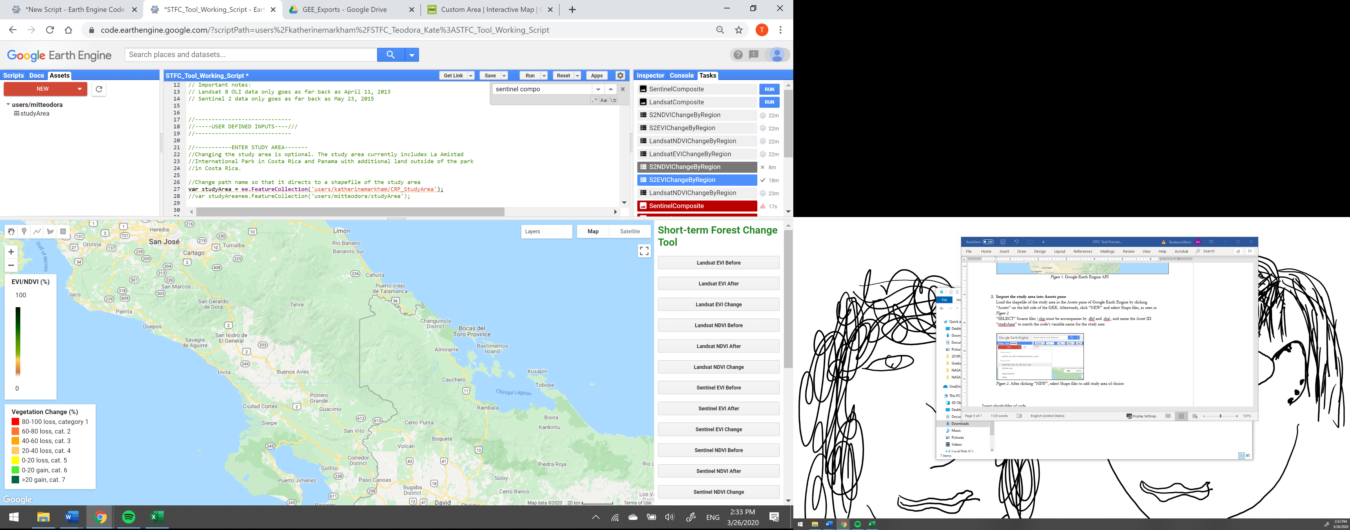

1. **Import regions for analysis (optional)**

Load a single shapefile that contains regions within the study area in the Assets pane of GEE by clicking “Assets” on the left side. Afterwards, click “NEW” and select Shape files*.* “SELECT” Source files (.shp must be accompanies by .dbf and .shx), and name the Asset ID. These are the regions for which statistics are calculated and exported as tables. Tables will appear under the “Tasks” bar.

1. **Change the path name (optional)**

Find the section of the code titled, “Enter Regions for Analysis” on line 110. Change the directory inside “ee.FeatureCollection()” to the GEE username and the asset name on line 115 (*Figure 4*).

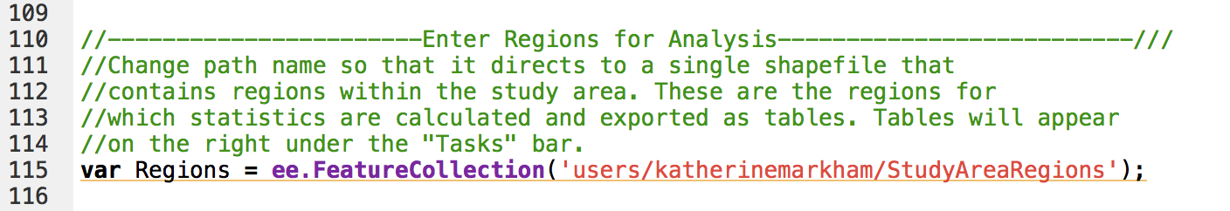

*Figure 4*. The “Enter Regions for Analysis” section of the code that imports the asset used for calculating mean change per region.

1. **Import regions for exporting Sentinel imagery (optional)**

Because Sentinel imagery is at 10m resolution, exporting it for the entire study region is not possible at this spatial resolution. To export Sentinel imagery at its original resolution, smaller regions must be used. Load shapefiles for each region within the study area in Assets pane of GEE by clicking “Assets” on the left side. Afterwards, click “NEW” and select Shape files*.* “SELECT” Source files (.shp must be accompanies by .dbf and .shx), and name the Asset ID.

1. **Change the path name (optional)**

Find the section of the code titled, “Enter Regions for Exporting Sentinel Imagery” on line 117. Change the directories inside “ee.FeatureCollection()” to the GEE username and the asset names on lines 127-130 (*Figure 5*). If you want to use more than four study regions, you will also need to change the User Interface on lines 1160-1172 and lines 1196-1286.

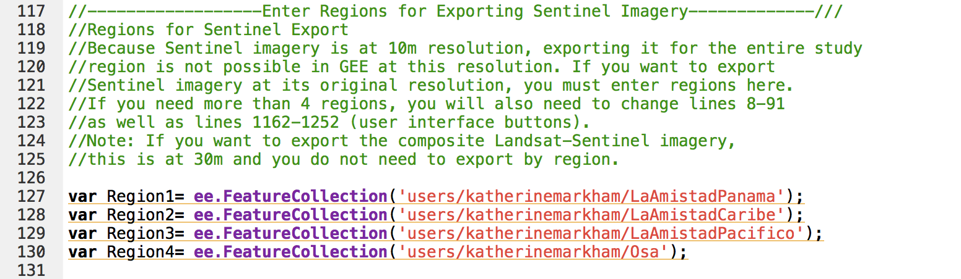

*Figure 5*. The section of the code where regions must be entered in order to export Sentinel imagery at 10m resolution.

1. **Change the date**

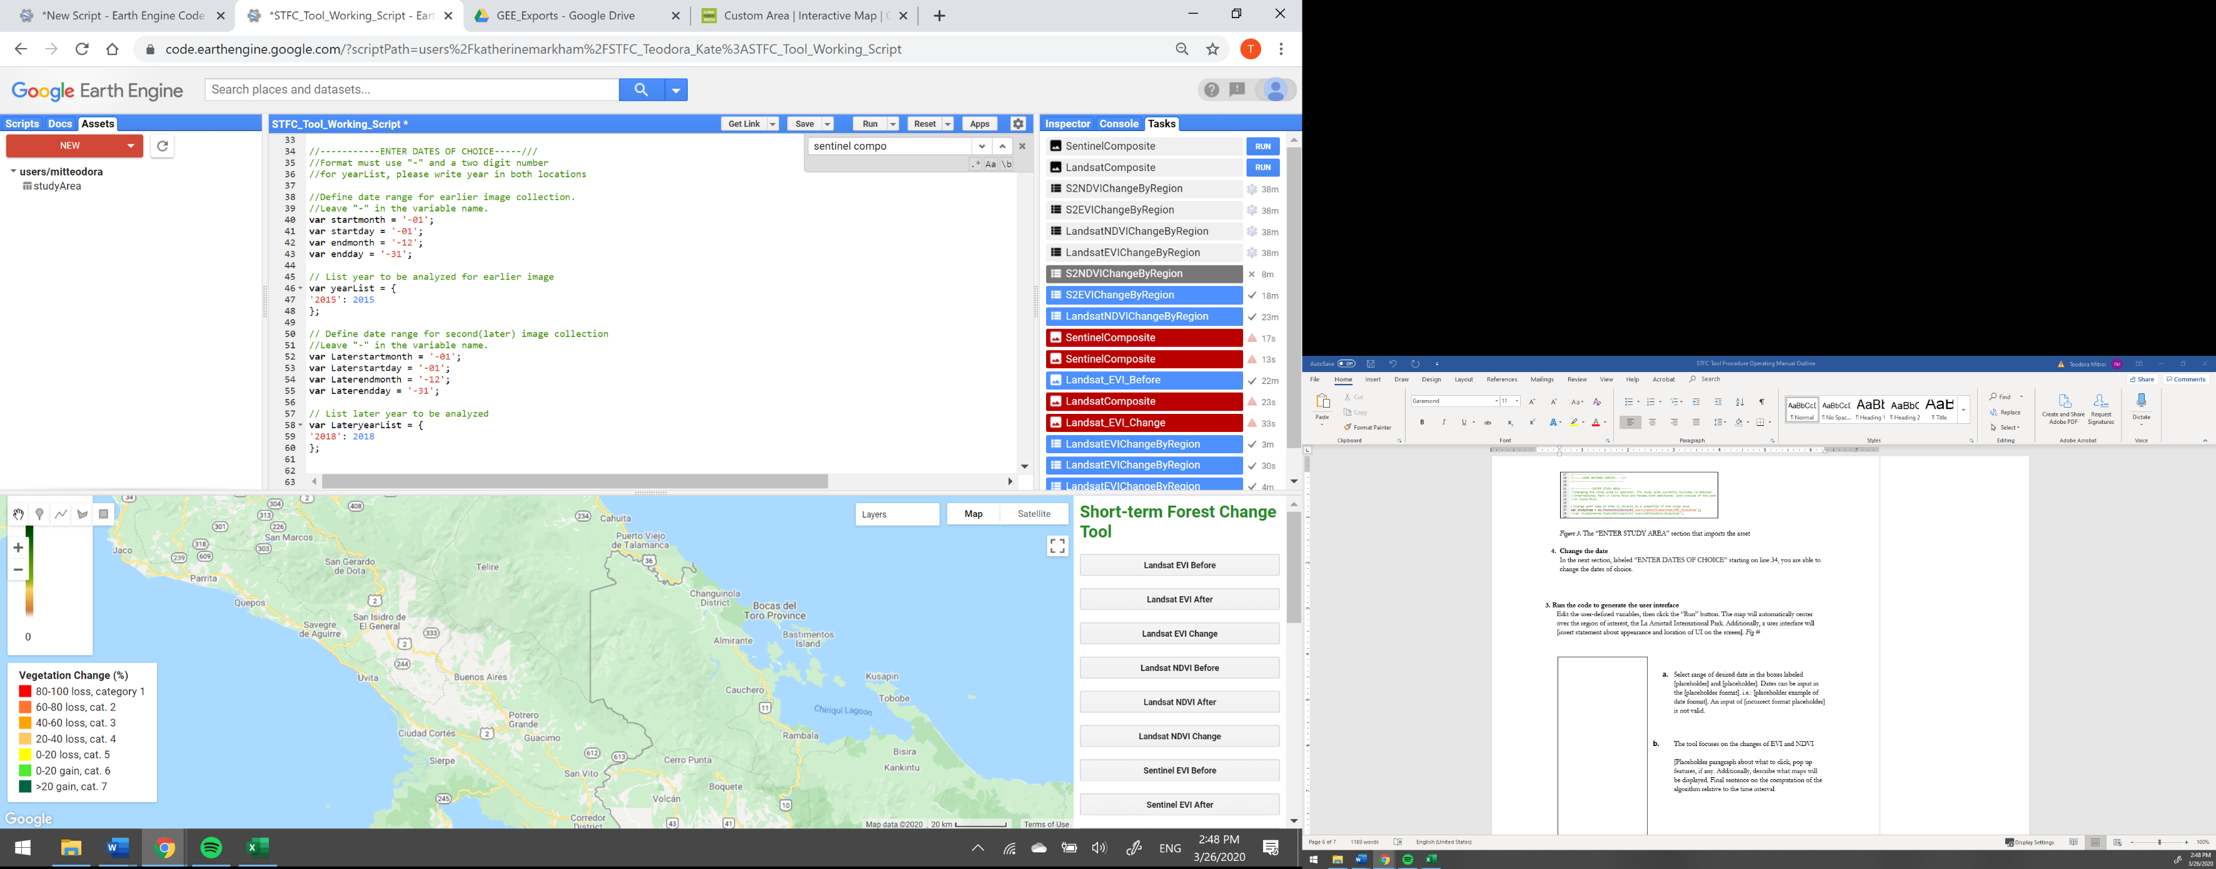In the next section, labeled “ENTER DATES OF CHOICE” starting on line 34, the user is able to change the dates of choice. For the earlier image collection, choose what month and day to begin the composite and what month and date to end the composite. Only change numerical values and no symbols. **Do not** erase the dashes (-) before the number. Choose the year as well, and write it twice, without breaking the format of {‘year’: year}.

The example below (*Figure 6*) makes a composite for the year of 2015 from January 1st to December 31st and compared it the composite for the year 2018 from January 1st to December 31st.

*Figure 6.* An example of date input section

**Important notes:** Landsat 8 OLI data only goes as far back as April 11, 2013. Sentinel 2 data only goes as far back as May 23, 2015. MODIS Vegetation Indices only go as far back as July 4th, 2002. Putting in dates before the May 2015 **will not** give the user the full capabilites of the tool.

1. **Run the code to generate the user interface**

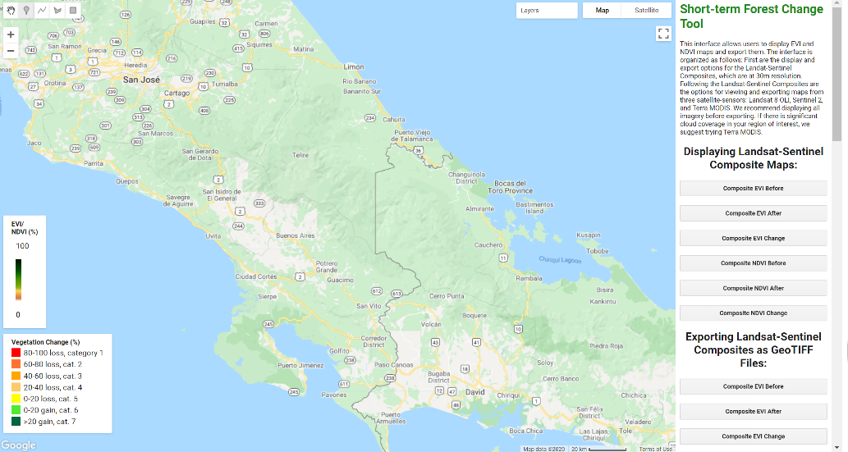Click the “Run” button in the GEE Code Editor. The map will automatically center over the study area. Additionally, a user interface will appear on the right of the map with several buttons, and two legends will show on the left (*Figure 7).*

*Figure 7.* The user interface

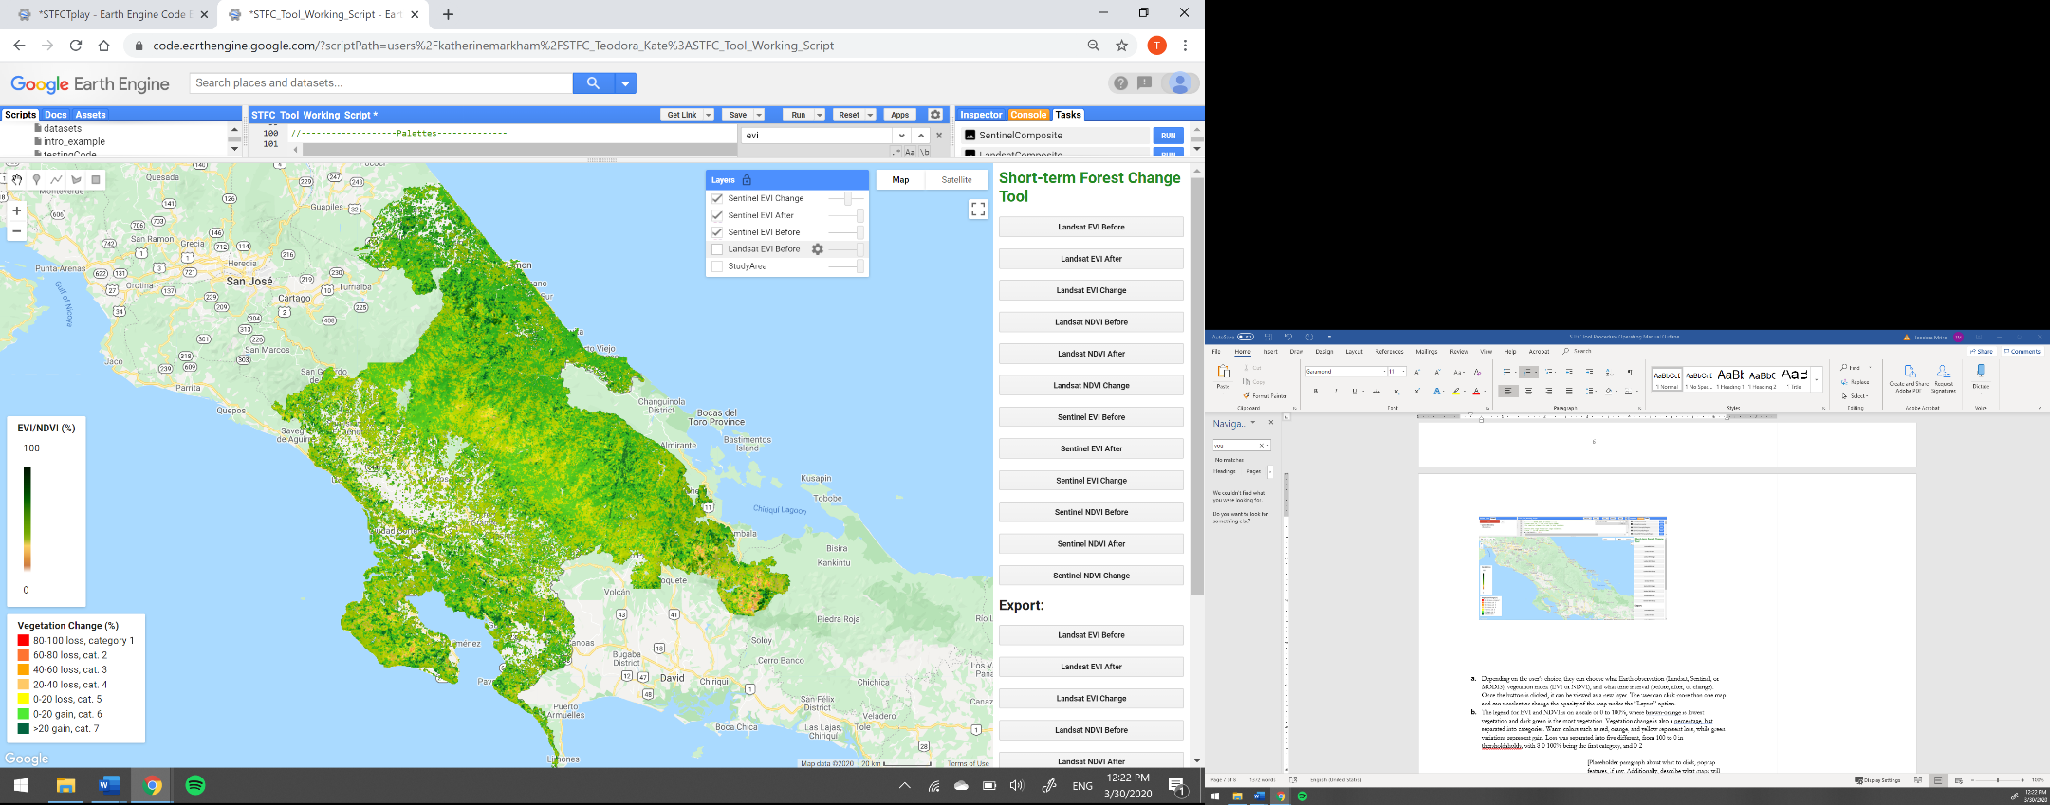

* 1. Depending on the user’s choice, they can choose what Earth observation (Landsat, Sentinel, or MODIS), vegetation index (EVI or NDVI), and what time interval (before, after, or change). Once the button is clicked, it can be viewed as a new layer. The user can click more than one map and can unselect or change the opacity of the map under the “Layers” option (*Figure 8*).

*Figure 8.* An example of maps in the Layers tab, with changes in opacity and unselected maps

* 1. The legend for EVI and NDVI is on a scale of 0 to 100%, where brown-orange is lowest vegetation and dark green is the most vegetation (*Figure 9*). Vegetation change is also a percentage but separated into categories. Warm colors such as red, orange, and yellow represent loss, while green variations represent gain. Loss was separated into five different categories, from 0 to 100 in increments of 20% to distinguish the level of severity of loss (*Figure 10).*

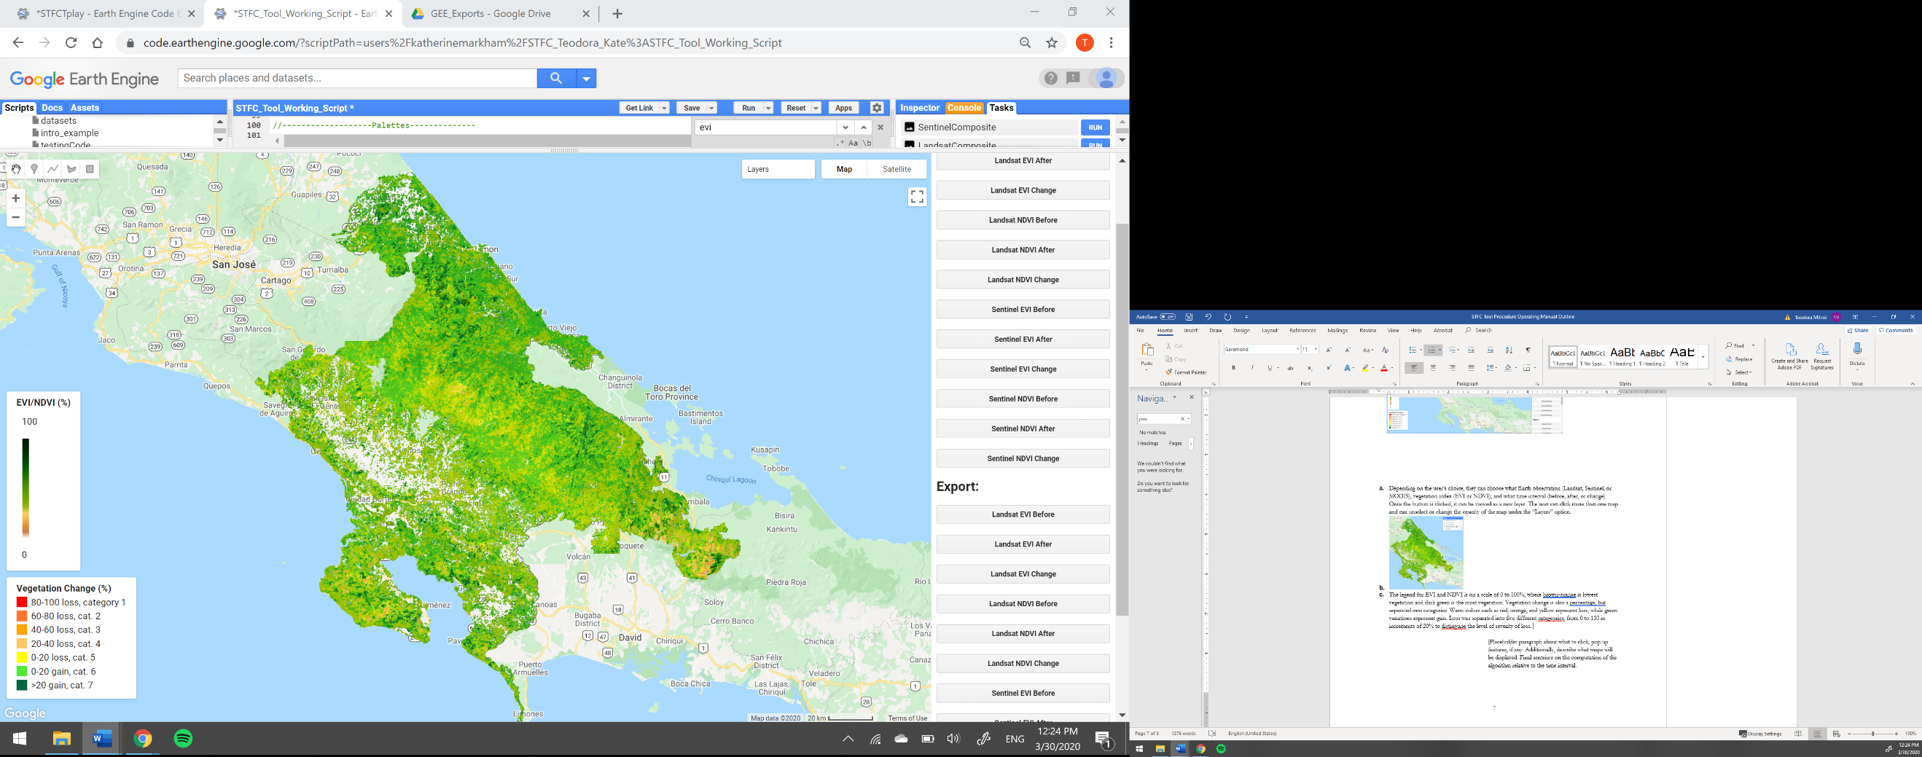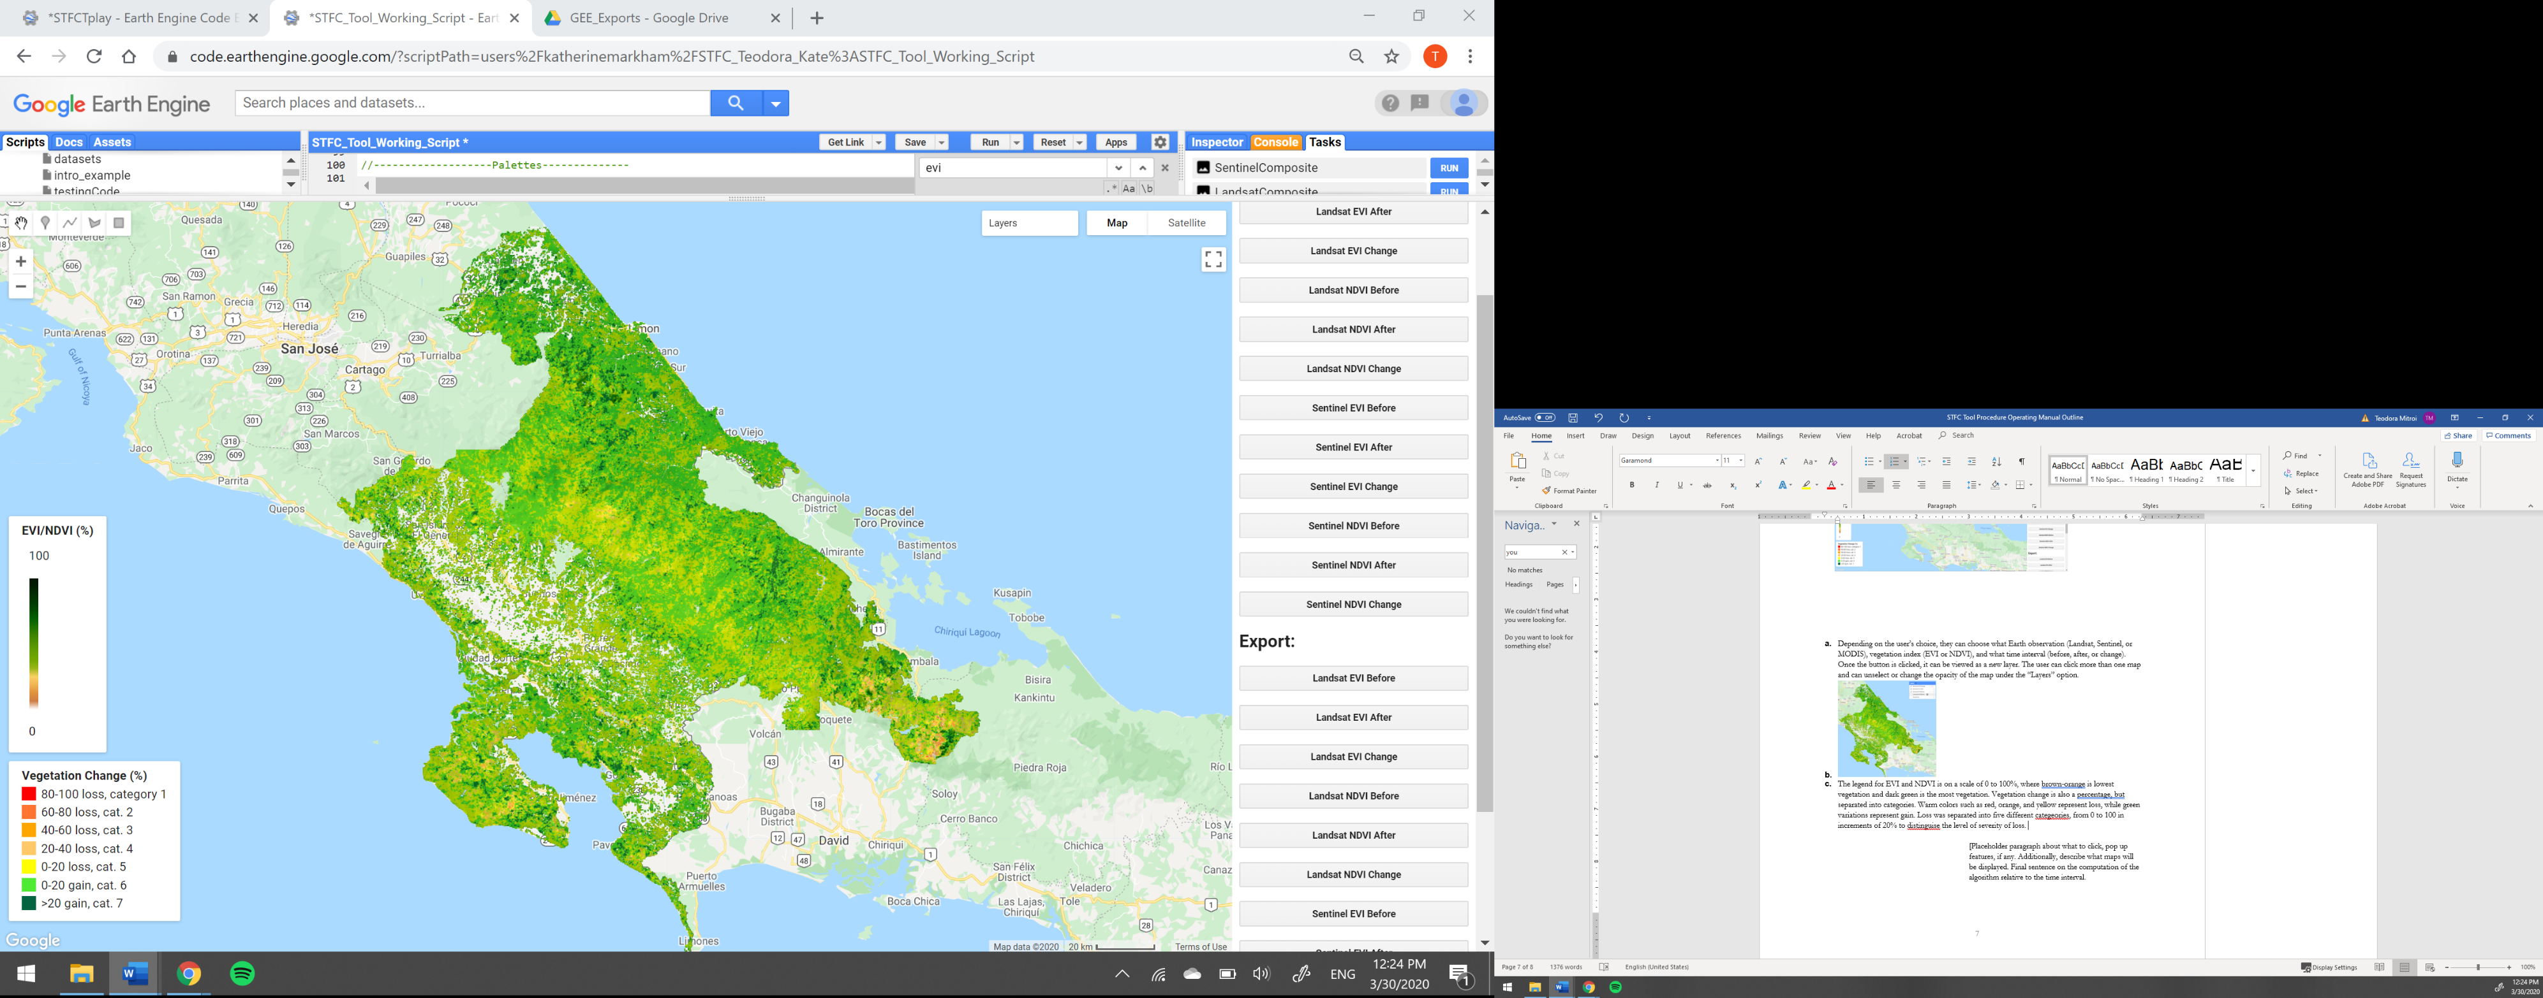

*Figure 10.* Vegetation change legend

*Figure 9.* EVI and NDVI legend

1. **Downloading Average Change**

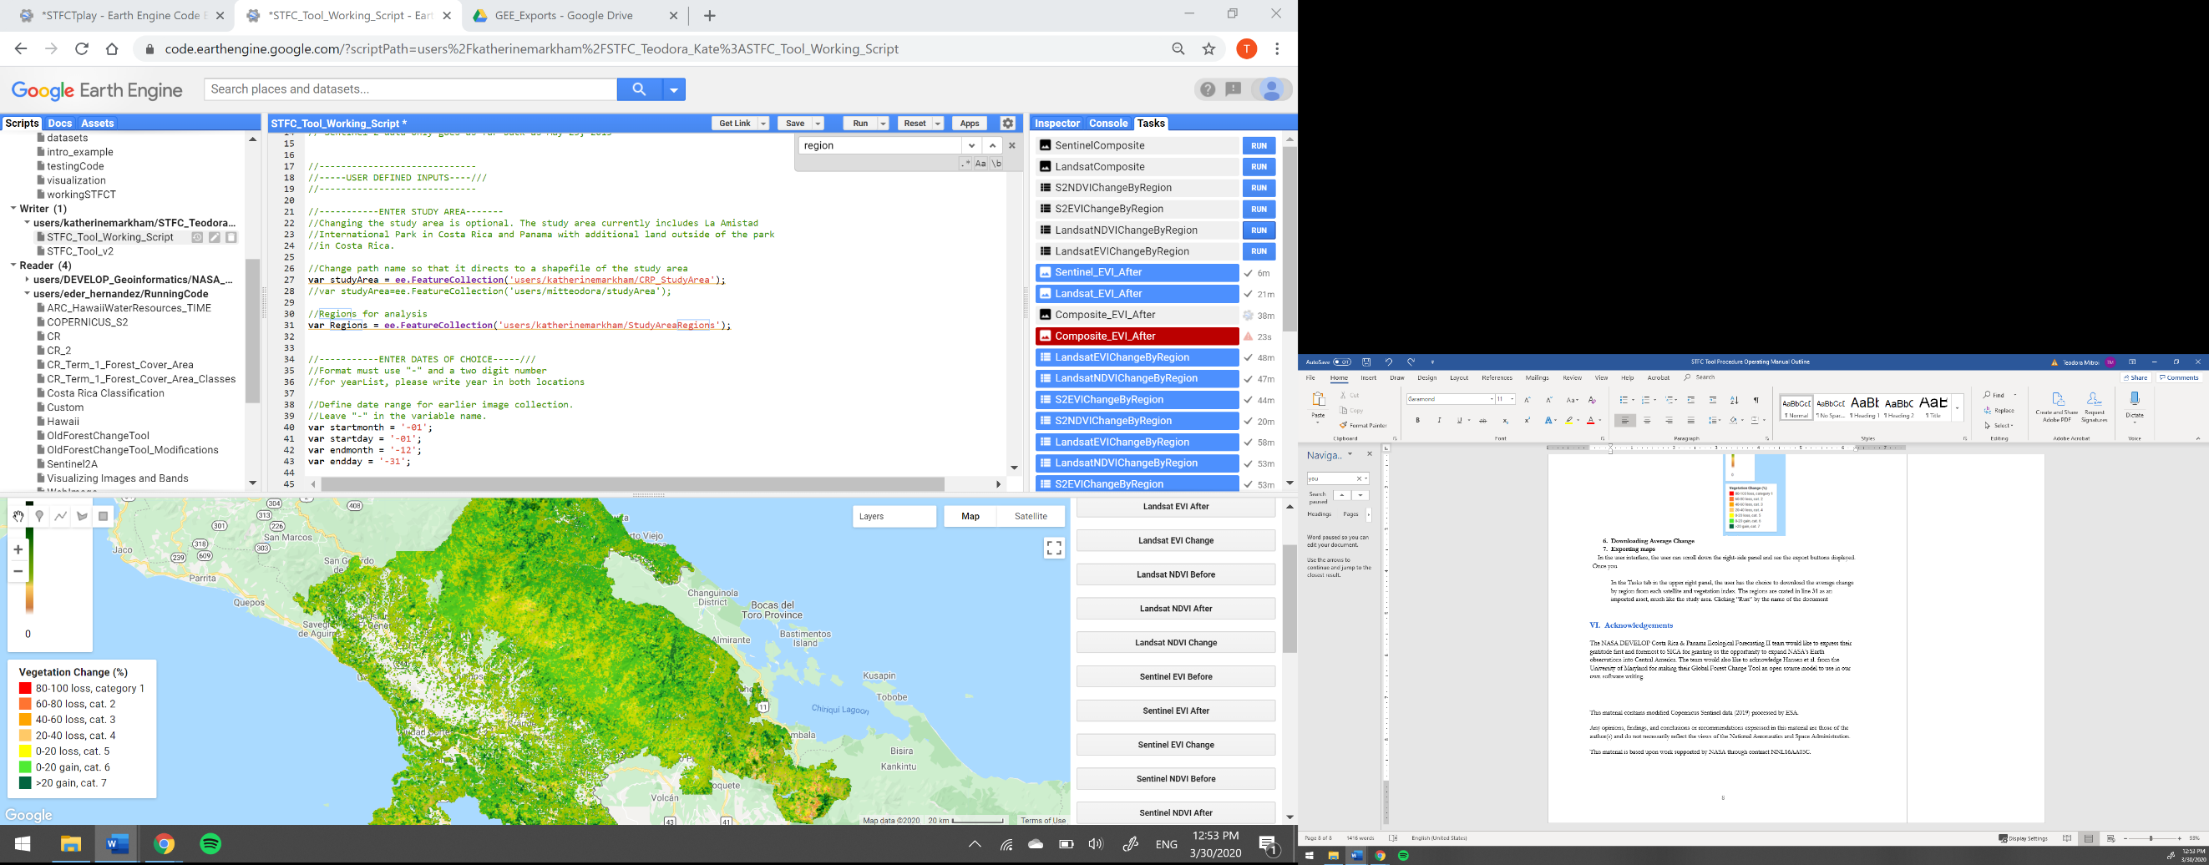In the Tasks tab in the upper right panel, the user has the choice to download the average change by region from each satellite and vegetation index. The regions are created in line 115 as an imported asset, much like the study area. They are composed of La Amistad Pacifico, La Amistad Caribe, and Osa of Costa Rica and La Amistad Park in Panama. Clicking “Run” by the name of the document. The document will be saved as a .csv in the user’s Google Drive account in the folder specified in line 166 in the code.

*Figure 11.* Task tab options

In addition, the user can export the Sentinel and Landsat composites as a GeoTIFF (*Figure 11*).

1. 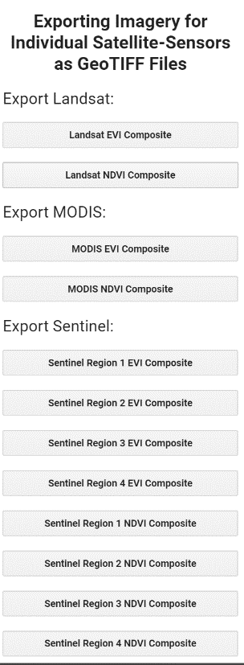**Exporting maps**

In the user interface, the user can scroll down the right-side panel and see the export buttons displayed (*Figure 10*). Once the user has clicked the map of choice, the Tasks tab will turn orange if they are not in the Tasks tab already. Click on the Tasks tab and click “Run” on the map you selected. Do this for any map of choice. The map will be exported as a GeoTIFF to the folder specified in line 166 in the code. Since Sentinel’s resolution is 10m, the file is large and will be cut into four regions (refer to steps 5 and 6). **Warning**: most files may take up to an hour to export, so please be patient.

*Figure 10.* Sentinel export buttons

1. **Explanation of Methodology**
2. **Earth Observations**

Landsat 8 Operational Land Imager (OLI), Sentinel-2 MultiSpectral Instrument (MSI) and Terra Moderate Resolution Imaging Spectroradiometer (MODIS) were used in the production of the tool. Landsat 8 and Sentinel-2 were chosen to provide a combination of moderate spatial (30m vs. 10m) and temporal (16-day vs. 10-day) resolution. Although MODIS has a low resolution in comparison to Landsat 8 and Sentinel-2 (500m in our case), its daily spatial resolution allows the user the see the best available pixel value from 16 days. Thus, every 16-day image shows low clouds, low view angle, and the highest NDVI/EVI value.

1. **Vegetation Indices**

Enhanced Vegetation Index (EVI) and Normalized Difference Vegetation Index (NDVI) were chosen to monitor the vegetation of the study area. EVI was chosen for the tool because it provides the sensitivity of the vegetation signal in high biomass regions. NDVI is a standard for in ecological studies, thus was included for versatility purposes, depending on the end user’s scope.

1. **Updating Hansen Forest Cover**

The Hansen Global Forest Change tool version 1.6 has several “bands” or variables, including “treecover2000” and “lossyear.” “Treecover2000” includes tree canopy cover for the year 2000, which is defined as vegetation taller than 5m in height. The team created a threshold of greater than 70% tree cover to account for possible plantations and other vegetation types (named var treeCoverThreshold”. Because the tool analyzes yearly tree canopy, the team updated the tree cover for every year until 2018, the last year “lossyear” has updated. “Lossyear” is the year of gross forest cover loss, which also includes the previous year’s forest cover gain. New variables were created to update “treeCoverThreshold” with every “lossyear”, for example, “var lossyear14=lossyear.eq(14)” and combined with “treeCoverThreshold.”

Depending on the user’s input year, for example, if the second year or “Lateryr” is 2014, the function “HansenUpdatecond” will mask out the non-treecover and only keep what is tree cover for that year, using the new, updated variables. This is to only calculate EVI and NDVI for forested areas, and narrow down to possible deforestation.

1. **Thresholding Change**

Thresholds have been placed for the change maps to easily see the severity of the forest cover change. The variables “setPalettesEVI” and “setPalettesNDVI” categorize the pixels into brackets of change, with red being 80-100% loss to >20% gain as dark green (*Figure 8*).

**V. Glossary of Terms**

**Central American Integration System (SICA)** – A United Nations affiliated regional economic integration system made up of member states from Belize, Costa Rica, Dominican Republic, El Salvador, Guatemala, Honduras, Nicaragua, and Panama as of October 2019

**Earth observations** – Satellites and sensors that collect information about the Earth’s physical, chemical, and biological systems over space and time

**Enhanced Vegetation Index (EVI)** – Optimized vegetation density measurement, improved sensitivity in high biomass regions with atmospheric corrections

$$EVI = 2.5×\frac{Near Infrared-Red}{Near Infrared+6×Red-7.5×Blue+1}$$

**GeoTIFF** – A GeoTIFF is a standard .tif or image file format that includes additional spatial (georeferencing) information embedded in the .tif file as tags

**Google Earth Engine (GEE)** – Cloud-based API for global data analysis

**Landsat 8 Operational Land Imager (OLI)** –Satellite and sensor launched February 11, 2013 by National Aeronautics and Space Administration (NASA) with 30-meter and 16- day temporal resolution

**Mesoamerican Biological Corridor (MBC)** – One of Central America’s most integrative conservation cooperatives made up of over 600 protected areas that connect diverse ecosystems and natural habitats in Panama, Costa Rica, Nicaragua, Honduras, El Salvador, Guatemala, Belize, and southern states in Mexico

**Terra Moderate Resolution Imaging Spectroradiometer (MODIS)** – Satellite and sensor launched December 18, 1999 by NASA with various resolutions (250m-1km) and spatial resolutions (1-16 days)

**Normalized Difference Vegetation Index (NDVI)** – A measurement of live vegetation density

$NDVI= \frac{Near Infrared-Red}{Near Infrared+Red}$

**Sentinel 2 MultiSpectral Instrument (MSI)** – Satellites and sensors launched June 23, 2015 by the European Space Agency with 10-meter spatial resolution and 10-day temporal resolution

**VI. Acknowledgements**

The NASA DEVELOP Costa Rica & Panama Ecological Forecasting II team would like to express their gratitude first and foremost to SICA for granting us the opportunity to expand the use of NASA’s Earth observations into Central America. Dr. Sergio Bernandes, the team’s science advisor from University of Georgia’s Department of Geography, assisted in configuring the code and troubleshooting. The team would also like to acknowledge Hansen et al. from the University of Maryland for making their Global Forest Change Tool an open source model to use in our own software writing.

This material contains modified Copernicus Sentinel data (2015-2020) processed by ESA.

Any opinions, findings, and conclusions or recommendations expressed in this material are those of the author(s) and do not necessarily reflect the views of the National Aeronautics and Space Administration.

This material is based upon work supported by NASA through contract NNL16AA05C.